Spectral coherence: USDJPY and USDCAD
Method 21 / daily log returns / Welch magnitude-squared coherence / Alpari D1 full available history

Study setup
Logical pair: USDJPY , USDCAD
Broker symbols: USDJPY_i , USDCAD_i
Snapshot: 2026-11-03_majors_alpari_D1
Timeframe: D1
Matched return window: 1999-01-05 to 2026-11-02 (UTC bar dates)
Matched return count n: 7186
Dropped unfinished last bar dated 2026-11-03 UTC after a tick-volume check against the prior complete day.
Welch: fs=1.0, nperseg=256, noverlap=128, window=hann, detrend=constant
Headline: gamma^2 nearest f=1/5; also 1/21 and 1/63
Complete matched rows (Excel): USDJPY-USDCAD_Spectral_D1.xlsx
Complete matched rows (HTML table): USDJPY-USDCAD_Spectral_D1_data.html

Method carried forward
Magnitude-squared spectral coherence gamma^2(f) measures shared linear power between matched daily log returns of close, ln(close_t / close_t-1), at each frequency f (cycles per day). Quotes are not inverted. Welch settings are frozen: fs=1, nperseg=256, noverlap=128, window=hann, detrend=constant. Headline is gamma^2 at the frequency bin nearest f=1/5 (five-day cycle from the formula sheet). Also reported: gamma^2 nearest f=1/21 and f=1/63, mean gamma^2 over the frequency grid, and phase of the cross-spectrum at the 1/5 bin. Coherence is unsigned (0 to 1); phase carries timing. Same-sample Pearson r is a side check only. This is not causation and not a trading signal.

Results (headline)
gamma^2 near 1/5: 0.014205
bin f (1/5): 0.199219
phase at 1/5 (rad): 1.787786
gamma^2 near 1/21: 0.001481
gamma^2 near 1/63: 0.007337
mean gamma^2: 0.027188
Pearson r: 0.027603

Target-frequency summary
period | target_f | f_bin | gamma2 | phase_rad
5 | 0.2 | 0.19921875 | 0.01420495 | 1.7877863
21 | 0.04761905 | 0.046875 | 0.00148139 | -1.1425099
63 | 0.01587302 | 0.015625 | 0.00733681 | -0.22179017

Conclusion
Headline gamma^2 near f=1/5 for USDJPY and USDCAD: 0.0142 (bin f=0.199219, phase=1.7878 rad). At ~1/21: 0.0015; at ~1/63: 0.0073. Mean gamma^2 = 0.0272. Pearson r = 0.0276. This is frequency-domain linkage, not a trading signal.

Charts
Daily closes

Daily log returns

Spectral coherence gamma^2(f)
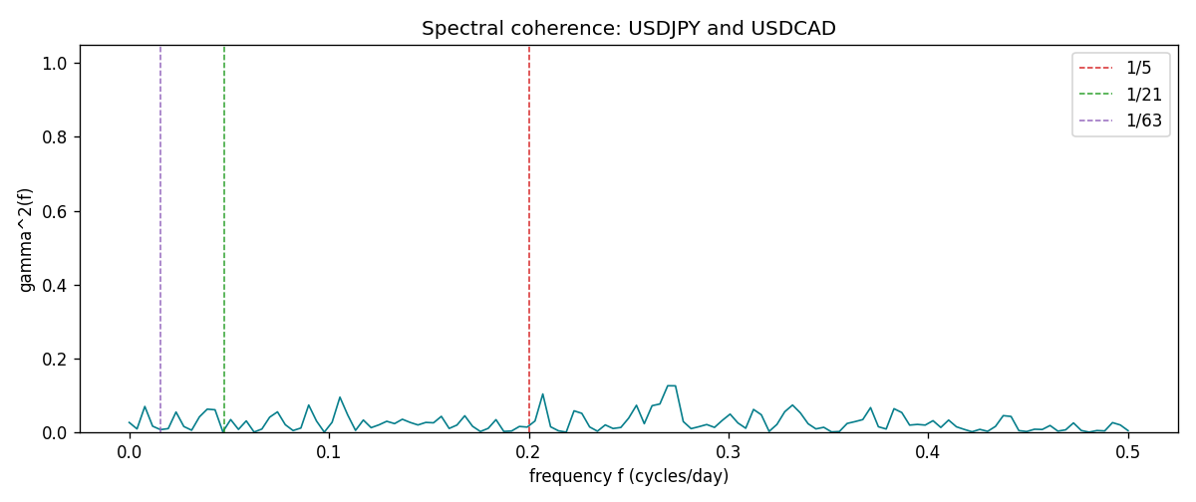

Data report
Matched rows and the coherence sheet are in the sibling Excel workbook named USDJPY-USDCAD_Spectral_D1.xlsx. Embedding all rows as a Word table is impractical; this file holds column summaries and the first and last 15 matched rows.
Columns: time, USDJPY_open, USDCAD_open, USDJPY_high, USDCAD_high, USDJPY_low, USDCAD_low, USDJPY_close, USDCAD_close, USDJPY_tick_volume, USDCAD_tick_volume, USDJPY_spread, USDCAD_spread, USDJPY_real_volume, USDCAD_real_volume, USDJPY_log_return, USDCAD_log_return
Column summaries (matched calculation rows)
column | count | mean | std | min | 25% | 50% | 75% | max
USDJPY_open | 7186 | 113.80748 | 19.222412 | 75.693 | 104.39025 | 110.981 | 120.70625 | 163.824
USDCAD_open | 7186 | 1.266789 | 0.16892251 | 0.9168 | 1.118445 | 1.2985 | 1.37213 | 1.6183
USDJPY_high | 7186 | 114.30511 | 19.284087 | 76.001 | 104.8685 | 111.4395 | 121.2675 | 163.978
USDCAD_high | 7186 | 1.2716872 | 0.16888037 | 0.9336 | 1.122975 | 1.303895 | 1.37655 | 1.619
USDJPY_low | 7186 | 113.28446 | 19.150257 | 75.402 | 103.88 | 110.53 | 120.1715 | 163.628
USDCAD_low | 7186 | 1.2622311 | 0.16895752 | 0.9056 | 1.114125 | 1.293555 | 1.367815 | 1.6102
USDJPY_close | 7186 | 113.82065 | 19.237762 | 75.811 | 104.38275 | 111.018 | 120.69375 | 163.851
USDCAD_close | 7186 | 1.2668036 | 0.16889539 | 0.916 | 1.118165 | 1.29848 | 1.372395 | 1.6137
USDJPY_tick_volume | 7186 | 106329.64 | 179429.89 | 149 | 9948.5 | 53187 | 92874.5 | 1803508
USDCAD_tick_volume | 7186 | 81037.769 | 147318.12 | 37 | 5546.5 | 40944 | 71631 | 1410818
USDJPY_spread | 7186 | 20.270804 | 17.617829 | 0 | 6 | 11 | 30 | 50
USDCAD_spread | 7186 | 23.436682 | 18.263202 | 0 | 9 | 17 | 40 | 60
USDJPY_real_volume | 7186 | 3.4776211e+10 | 1.6092546e+11 | 0 | 0 | 0 | 0 | 3.8834203e+12
USDCAD_real_volume | 7186 | 1.8381818e+10 | 9.6701063e+10 | 0 | 0 | 0 | 0 | 2.5751613e+12
USDJPY_log_return | 7186 | 5.053e-05 | 0.00620694 | -0.03908203 | -0.00319936 | 0.00011986 | 0.0034094 | 0.05184024
USDCAD_log_return | 7186 | -1.555e-05 | 0.00514357 | -0.03859748 | -0.00283709 | 4.741e-05 | 0.00272359 | 0.03436319
First 15 matched rows (selected columns)
time | USDJPY_log_return | USDCAD_log_return
1999-01-05 | -0.00017868311 | -0.010131666
1999-01-06 | 0.0075660159 | -0.0003306769
1999-01-07 | -0.012851583 | 0.0015202092
1999-01-08 | -0.0047719894 | -0.0020495197
1999-01-11 | -0.016195423 | -0.0035137769
1999-01-12 | 0.032310364 | 0.0066194721
1999-01-13 | 0.0081373171 | 0.0045420214
1999-01-14 | 0 | 0.0069376546
1999-01-15 | 0.0055343401 | -0.0056905671
1999-01-18 | 8.7600193e-05 | 0.00098344542
1999-01-19 | -0.0056219403 | 0.002748513
1999-01-20 | -0.0053879917 | -0.0059646885
1999-01-21 | 0.0084664056 | -0.0042823796
1999-01-22 | 0.0060412564 | 0.0025057712
1999-01-25 | -0.0073594164 | 0.00085579808
Last 15 matched rows (selected columns)
time | USDJPY_log_return | USDCAD_log_return
2026-10-13 | -0.0018932826 | -0.0046395653
2026-10-14 | 7.5800166e-05 | 0.0015184751
2026-10-15 | -0.0018524319 | -0.0036101503
2026-10-16 | -0.00037976126 | -0.0034322068
2026-10-19 | 0.0034946841 | -0.0018835331
2026-10-20 | -0.0022546642 | -0.0037066008
2026-10-21 | -0.00032883504 | -0.00084691787
2026-10-22 | -0.0085942669 | -0.0026307268
2026-10-23 | 0.00035080446 | 2.85545e-05
2026-10-26 | 0.0041238746 | 5.7106554e-05
2026-10-27 | 0.0027651658 | 0.0025379458
2026-10-28 | -0.00095679538 | -0.0038379274
2026-10-29 | -0.00038043789 | -0.00011436495
2026-10-30 | -0.0010596481 | -0.0010298736
2026-11-02 | 0.0026438521 | 0.00061519094
First 15 frequency bins
f | gamma2 | phase_rad | period_days
0 | 0.02676638 | 0 | inf
0.00390625 | 0.00924885 | -1.7805627 | 256
0.0078125 | 0.07008957 | -1.0409966 | 128
0.01171875 | 0.01668327 | 0.03934019 | 85.333333
0.015625 | 0.00733681 | -0.22179017 | 64
0.01953125 | 0.01008386 | -0.00544059 | 51.2
0.0234375 | 0.05505143 | 0.74554764 | 42.666667
0.02734375 | 0.01578158 | 2.515746 | 36.571429
0.03125 | 0.00574044 | -0.92508308 | 32
0.03515625 | 0.0419864 | -0.17732631 | 28.444444
0.0390625 | 0.06280544 | 0.12298634 | 25.6
0.04296875 | 0.06110692 | 0.22341133 | 23.272727
0.046875 | 0.00148139 | -1.1425099 | 21.333333
0.05078125 | 0.03464928 | -1.714163 | 19.692308
0.0546875 | 0.00798344 | -0.88495689 | 18.285714

